**“Intelligence +” continues to make efforts to become an important support point for the construction of integrated media**

Source: [Consumer Daily](http://www.xfrb.com.cn/article/jjzs-tzsc/09474482387282.html)

2020-11-24

<https://www.rmlt.com.cn/2020/1124/599636.shtml>

On November 21, the first China (Beijing) International Audiovisual Conference was held in Beijing. Wang Wei, Chief Information Officer of Sina Group and Dean of Sina AI Media Research Institute, was invited to attend the Media Convergence Summit and shared the key role of intelligent media technology in driving media convergence in depth.

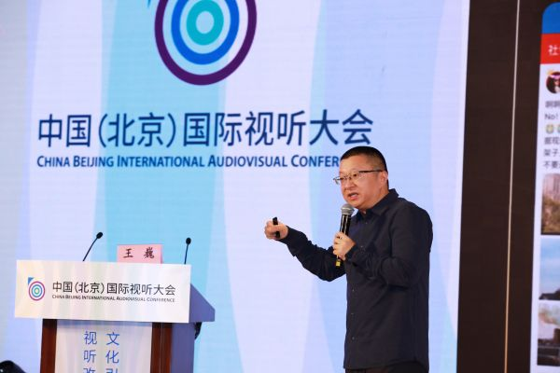

Media convergence is the development direction of the media industry in the Internet era. In 2020, the construction of the domestic omni-media communication system has entered the fast lane. Wang Wei believes that at the key node of media convergence going deeper, content is the core of media convergence, while technology continues to play the role of the primary productive force and becomes the support point for the construction of integrated media.

The intelligent economy in the era of converged media, supported by technology, has broken the original social connection structure and driven tremendous changes in the media ecosystem. Wang Wei said that the most important role of "intelligence +" in driving the innovative reconstruction of media production processes is to improve efficiency, especially in the three most critical links of information collection, content production, and content distribution.

Wang Wei introduced that in terms of information collection, the Eagle Eye platform independently developed by Sina News can realize intelligent all-media monitoring of hot information. There are also 5G drones that have emerged in recent years equipped with sensor equipment to collect information, which has greatly improved work efficiency; in terms of content production, domestically, there is Xinhua News Agency's "AI synthetic anchor" reporting news, and internationally, the Associated Press uses AI to drive financial reporting. Sina has also launched the "Cloud Cut" system based on intelligent video editing, which has greatly improved the production efficiency of video content; in terms of content distribution, Sina News has launched personalized intelligent recommendations, and has focused on the layout of a panoramic ecosystem to distribute high-quality content to more scenarios and devices in addition to mobile clients, including social media, smart speakers, smart homes, smart wearable devices, connected driving car screens, and more.

During the meeting, Wang Wei also shared his views on the new development trend of China's smart media. Wang Wei pointed out that only by taking content construction as the foundation, advanced technology as the support, and innovative management as the guarantee, can the media accelerate the in-depth integration and development of the media. Whether it is a media organization or an Internet company, they should adopt a more open mind, seek mutual benefit, and jointly promote the construction of a media integration technology platform.